- We suspect April’s surprise rise in UK mortgage approvals and the sharp fall in house prices reported by Nationwide in May will both prove to be anomalies. The steep increase in mortgage interest rates since the Middle East conflict began will start to weigh on mortgage activity soon. But tight supply should mean prices remain resilient.
- External Monetary Policy Committee member Megan Greene offered a strong hint she will vote for a rate hike on June 18. But Governor Andrew Bailey again offered a more dovish take, and the chances that policy will be tightened at this month’s meeting look low.
The housing market was one of the parts of the UK economy that looked most vulnerable to the tightening in financial conditions since the Middle East conflict began. Our new home buyer affordability index is based on mortgage repayment costs for the average property with two- and five-year fixed-rate mortgages. In Q4 2022, following a spike in mortgage rates triggered by the Truss government's mini-Budget, our indicator pointed to a 33% overvaluation in prices. Subsequently, there was a steady improvement, and before the Middle East conflict began, our index showed house prices were only 4% overvalued compared to the 2000-2020 average. But the sharp rise in mortgage rates over the past few months has widened the valuation gap to just over 10% (Chart 1).
At face value, data published this week offered mixed signals on the impact on prices and activity so far. The Bank of England reported a pickup in mortgage approvals to a 15-month high in April. But Nationwide said that its measure of house prices fell by 0.6% m/m in May, while Halifax reported a 0.1% m/m drop that month.
Chart 1: The recent rise in mortgage rates has reversed some of the improvement in affordability
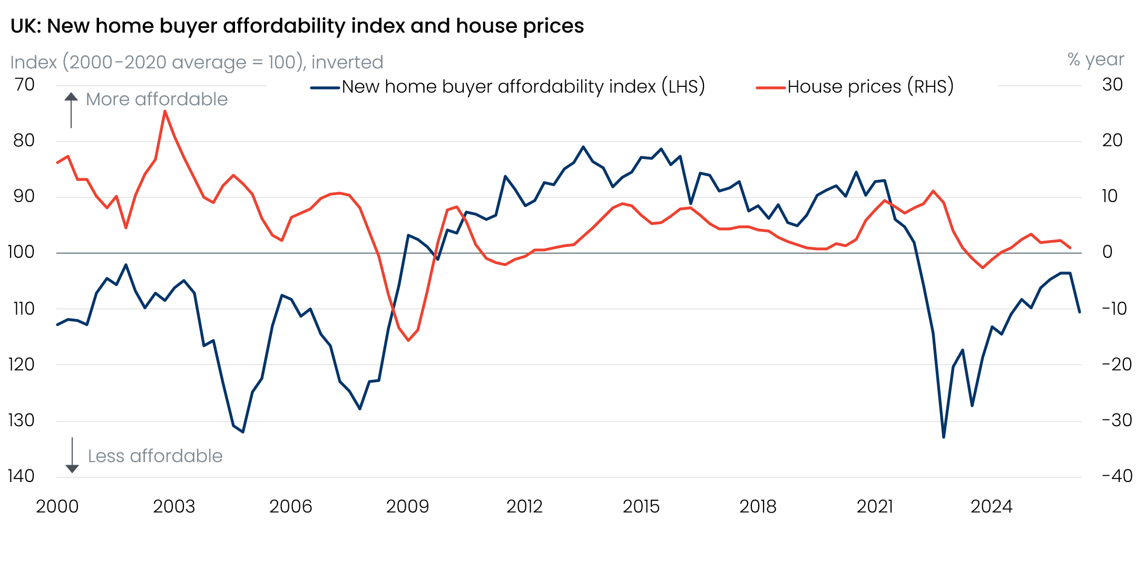
Sources: Oxford Economics, Haver Analytics

There’s good reason to view the BoE and Nationwide outturns with scepticism. The BoE tends to make relatively large and erratic seasonal adjustments to its approvals data each April, reflecting the loss of working days due to Easter. We suspect April’s apparent sharp pickup in activity will prove an anomaly. Over recent years, approvals have tended to follow changes in mortgage interest rates with a brief lag (Chart 2). Given the extent of the deterioration in affordability in recent months, it seems likely that demand will falter soon.
Chart 2: History suggests weaker mortgage affordability will cause approvals to drop back
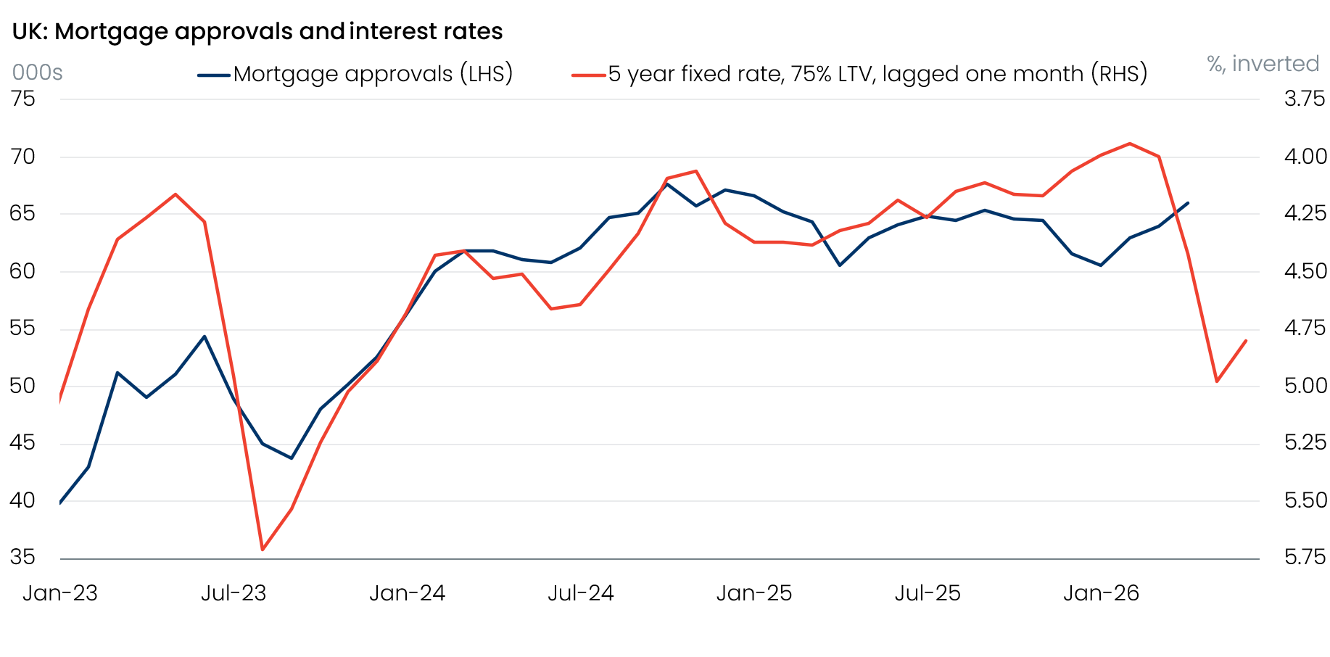
Source: Haver Analytics
In a similar vein, Nationwide’s sharp fall in house prices in May looks like payback for four successive strong readings rather than a reason for concern. Supply remains tight, with levels of housebuilding and forced sales low. So we expect to see a return to the low activity, stable house prices environment that’s characterised recent periods of weaker affordability, rather than a more serious housing downturn.
The behaviour of the BoE’s Monetary Policy Committee will be a key influence on where mortgage rates go from here. In a speech this week, external member Megan Greene dropped a strong hint that she will vote to hike at the next meeting on June 18. Greene said she considered voting to hike in April but judged it would be a mistake if the conflict ended immediately. She argued it was most likely that second-round effects from the energy shock will emerge and land somewhere between the two higher inflation scenarios presented in April’s Monetary Policy Report, even going as far as publishing charts showing how such a scenario would look. Greene also named the new scenario after herself, but then suggested this scenario should not be interpreted as her central case. Abstracting from this confusing piece of communication, the core message of the speech and her opinion piece in the Financial Times was that rates must rise sooner rather than later.
But this remains a minority view on the MPC. Giving evidence to the House of Lords Economic Affairs Committee this week, Governor Andrew Bailey reiterated the more dovish message he’d delivered in a speech last week. The Governor is a more reliable bellwether of MPC sentiment and current market pricing, which puts the chances of a June rate hike at 10%, looks about right.
Bailey did acknowledge that the MPC can’t wait for hard evidence of second round effects to emerge before acting. But he cited evidence that the labour market is softening and that firms plan to absorb more of the cost increases as reasons for being less concerned about second round effects. May’s BoE Decision Maker Panel was consistent with this view, and we expect both conditions to remain in place, keeping the BoE in a holding pattern.

The week ahead
Next week’s only major release is the GDP data for April. Output rose on a monthly basis in each month of Q1, but we suspect moving or residual seasonality exaggerated the strength. In other years since the pandemic, the Q1 strength has begun to unwind from April, and we expect this to be the case again this year. The case for a chunky April fall in output is backed by a sharp fall in retail sales that month, and by March having seen spikes in output in a number of sectors – including manufacturing, construction, accommodation services, communications, and art and recreation – which look hard to justify and will likely reverse. We pencil in a 0.3% m/m fall in GDP in April.
Table 1: Week ahead calendar
Date | Events | Period | Measure | Unit | Previous | Forecast
Jun 12 | GDP | Apr | m/m | % | 0.3 | -0.3
Jun 12 | GDP | Apr | 3m/3m | % | 0.5 | 0.6
Jun 12 | Index of services | Apr | m/m | % | 0.3 | -0.4
Jun 12 | Index of services | Apr | 3m/3m | % | 0.8 | 0.7
Jun 12 | Manufacturing output | Apr | m/m | % | 1.2 | -0.6
Jun 12 | Manufacturing output | Apr | y/y | % | 1.2 | 0.0
Jun 12 | Industrial production | Apr | m/m | % | -0.2 | 0.1
Jun 12 | Industrial production | Apr | y/y | % | 0.0 | -0.1
Jun 12 | Construction output | Apr | m/m | % | 1.5 | -0.6
Jun 12 | Construction output | Apr | y/y | % | -0.3 | -1.7
Jun 12 | UK trade | Apr | Trade balance | £bn | -9.7 | -5.0
Jun 12 | UK trade | Apr | Visible balance | £bn | -27.2 | -22.5
Source: Oxford Economics

Key forecasts
Table 2: UK forecast overview
(ANNUAL PERCENTAGE CHANGES UNLESS SPECIFIED)
 | 2024 | 2025 | 2026 | 2027 | 2028 | 2029
GDP | 1.0 | 1.4 | 0.7 | 0.7 | 1.8 | 1.7
Private consumption | -0.1 | 0.8 | 0.6 | 0.4 | 1.5 | 1.8
Fixed investment | 1.7 | 4.3 | 0.3 | 1.5 | 2.5 | 2.1
Government consumption | 2.9 | 1.6 | 1.3 | 1.6 | 1.4 | 1.2
Consumer prices | 2.5 | 3.4 | 3.4 | 2.7 | 1.9 | 2.0
Unemployment rate (%) | 4.3 | 4.9 | 5.4 | 5.6 | 5.1 | 4.7
Current a/c balance (% of GDP) | -3.0 | -2.4 | -3.8 | -3.2 | -2.6 | -2.5
Government balance (% of GDP) | 5.2 | 5.0 | 4.0 | 3.8 | 3.0 | 2.6
Central bank policy rate (%, EOP) | 4.75 | 3.75 | 3.75 | 3.50 | 3.00 | 2.75
10yr govt. bond yield (%, EOP) | 4.57 | 4.47 | 5.13 | 4.57 | 3.87 | 3.55
Exchange rate (US$ per £, EOP) | 1.25 | 1.35 | 1.30 | 1.30 | 1.30 | 1.30
Exchange rate (euro per £, EOP) | 1.21 | 1.15 | 1.12 | 1.10 | 1.10 | 1.10
Source: Oxford Economics
Table 3: Quarterly forecasts for the UK
 | 2026 |  |  |  | 2027
 | Q1 | Q2 | Q3 | Q4 | Q1 | Q2 | Q3 | Q4
GDP (% year) | 1.1 | 0.9 | 0.6 | 0.4 | 0.2 | 0.5 | 1.0 | 1.3
CPI inflation (% year) | 3.1 | 3.0 | 3.6 | 3.9 | 3.7 | 3.0 | 2.3 | 1.9
Bank Rate (%, EOP) | 3.75 | 3.75 | 3.75 | 3.75 | 3.75 | 3.75 | 3.75 | 3.50
10yr gilt yield (%, EOP) | 4.88 | 5.10 | 5.14 | 5.13 | 5.09 | 4.96 | 4.78 | 4.57
US$ per £ (EOP) | 1.32 | 1.34 | 1.32 | 1.30 | 1.30 | 1.30 | 1.30 | 1.30
Euro per £ (EOP) | 1.14 | 1.16 | 1.14 | 1.12 | 1.11 | 1.10 | 1.10 | 1.10
Source: Oxford Economics

Latest Country Economic Forecast:
May 21, 2026

Recent publications

Data Insights
PMI signals a late spring slowdown
Mortgage approvals marched higher in April, despite costlier deals
Manufacturing strength won’t last
Public finances softer than expected
Weaker retail sales in April supports the case for Q2 slowdown

Research Briefings
Is a more optimistic view on recent productivity trends justified?
Debt predicament – structural weakness and a credibility deficit
Are European countries with high AI use seeing higher productivity growth?
Weak real incomes set to subdue consumer spending
Why 5% 10-year gilt yields are here to stay

Contacts

Oxford Economics' UK team
- Andrew Goodwin – Chief UK Economist – agoodwin@oxfordeconomics.com
- Edward Allenby - Senior UK Economist - eallenby@oxfordeconomics.com

